Writing a letter to your MP or councillor
 | Easy read guidance for writing to your local MP or councillor to ask them to visit you.
 | An MP is a person who people voted for to make decisions in your local area. It means Member of Parliament.
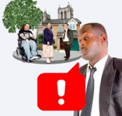 | A councillor is someone who represents your local area and raises awareness of issues. Councillors work for your local council.
 | The National Care Forum work with [insert name of provider] who provide your care and support.
 | Together the National Care Forum and [insert name of provider] are running a campaign called ‘Speak Up For Care’ as they want more people to know about social care.
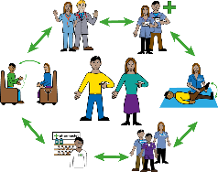 | National Care Forum and [insert name of provider] also want care workers like the people who support you to be paid better and be respected more.
 | National Care Forum and [insert name of provider] want your help with their campaign.
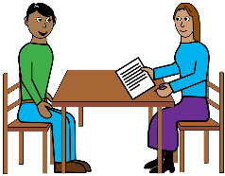 | National Care Forum and [insert name of provider] wondered if you might like to meet your local MP or councillor so you can tell your local MP or councillor about the support you receive.
 | Some MPs and councillors don’t know enough about how care and support works.
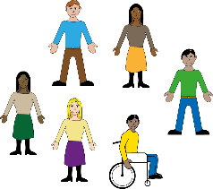 | National Care Forum and [insert name of provider] want MPs and councillors to know more about how people receive care and support and how it helps them to live life to the fullest.
 | Knowing more would help MPs and councillors make good decisions about the care and support people get.
 | MPs and councillors could find out more about the care and support people by visiting people where they live.
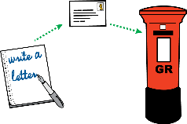 | Would you like to help by writing a letter to your local MP or councillor and inviting your local MP or councillor to visit you?
 | If you would like to do this, you can use our letter template.
 | The letter template is in easy read too.
 | To download the template go to https://www.nationalcareforum.org.uk/voice/speak-up-for-care/].
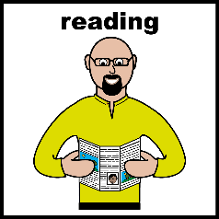 | After you’ve downloaded the letter you can print it and read it.
 | You can also chose to edit your letter on a computer.
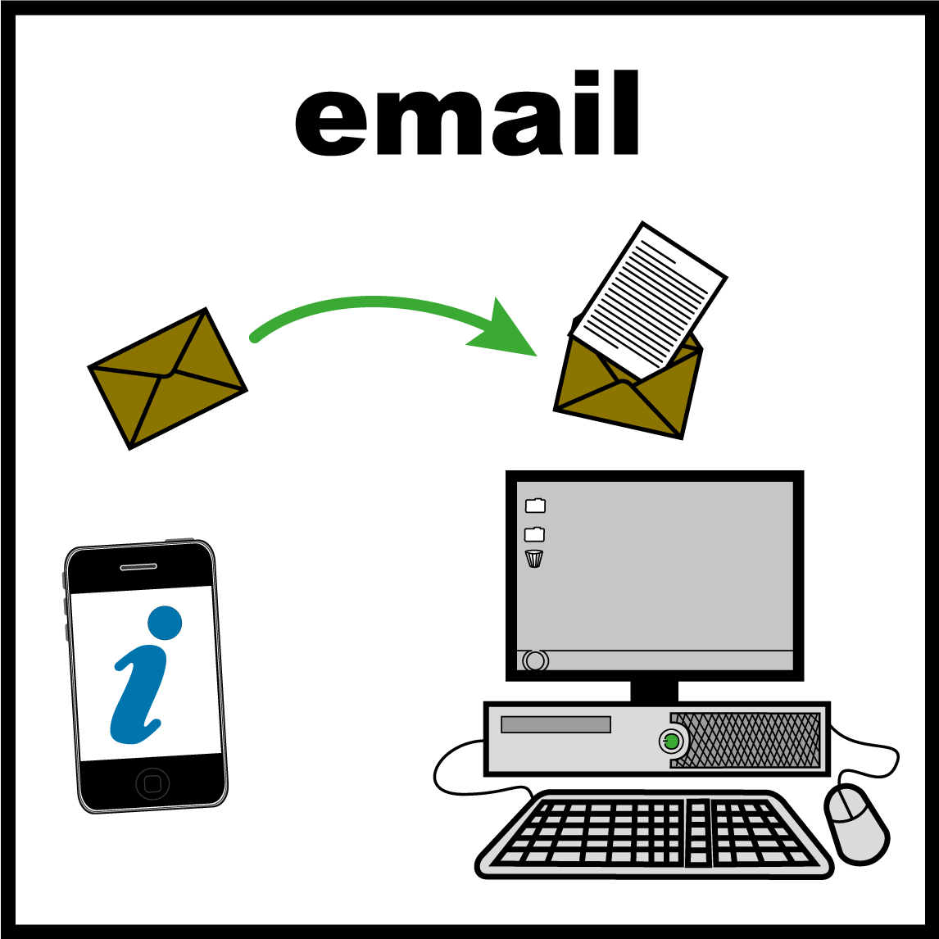 | You can then ask your support worker to help you send it your local MP or councillor by email.
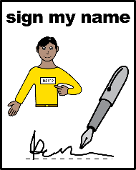 | And if you are happy with it you can sign it or just write your name at the bottom.
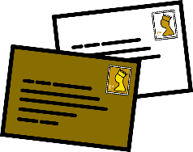 | Then put it in an envelope with the name and address of the MP or councillor on the front. You can find your local MP and their contact details by going to this website: https://members.parliament.uk/FindYourMP
 | You can find your local councillor and their contact details by going on this website: https://www.gov.uk/find-your-local-councillors
 | You might need to write to the MP’s Parliamentary Office if there is no other address listed for them.
 | You should also be able to find the email address of the person you want to send the letter to on this website.
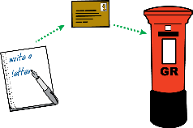 | Pop a stamp on the envelope and post it in the post box.
 | Or if you want to send your letter by email you could ask your support worker to help you do this.

Other ways you can help

 | We need photographs or videos of people who support our campaign.
 | Would you like to be in any campaign photos or videos?
 | Would you like your name to be in the campaign?
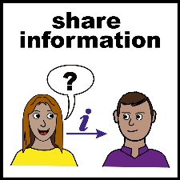 | If you are happy to be in any photos or videos, ask your support worker to share them with us.
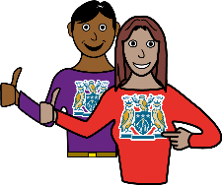 | Your support worker might also want to be in the photos or videos too which would be nice.
 | If you have your own social media accounts you could also share pictures or videos there.
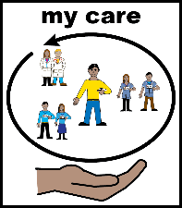 | If you do a post supporting our campaign it would helpful if you tag in the organisation who support you.
 | You could also put #speakupforcare in the picture caption.
 | This will help other people find out about the #speakupforcare campaign.

What will happen next
 | If the MP or councillor wants to come and visit you the MP or councillor will reply to your letter.
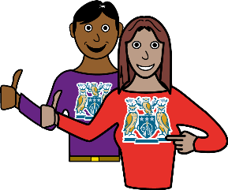 | In the letter the MP or councillor will say when the MP or councillor can come and visit you and your support worker.
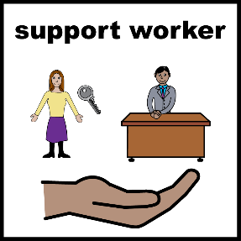 | You will then be able to arrange the visit and your support worker can help.
 | The MP or councillor might say that there will be other people coming as well.
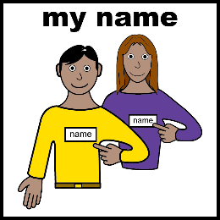 | We think you should ask for the names of the people who are coming.

What will happen when the people visit your home
 | When people visit you might want to show them your home.
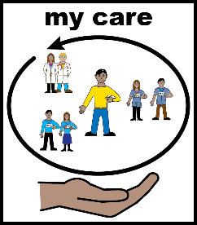 | You can also tell the people about the care and support you have.
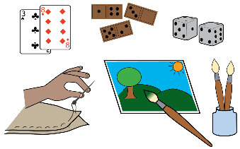 | You can tell the people how it helps you live your best life.
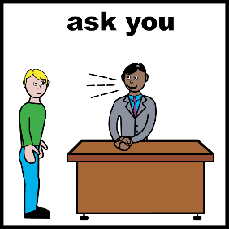 | The people might ask you questions about this.
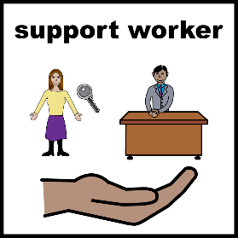 | And the people might ask if they can talk to your support worker.
 | The people might also ask if someone that comes with them can take your photo or do a video of you.
 | The people might say that the photo might be used in the local newspaper.
 | The people might also write some things down about the visit.
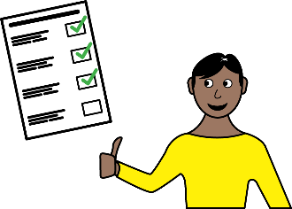 | You always have a choice about whether photos or videos of you or the things you say get used in the campaign.
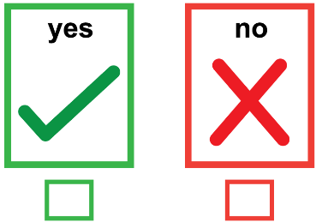 | If you don’t want photos or videos of you to be used or for the things the people have written down about you to be used you can tell your support worker.
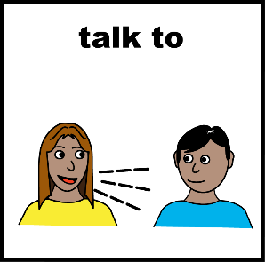 | If you are happy for the things the people write down or the photos or videos to be used you can tell the people.

What might happen after the visit
 | You might then be in the local newspaper so your family and friends might see you.
 | The photos or video or things about the visit might also be used on social media.

