 | Easy read letter template to write to local MP or councillor
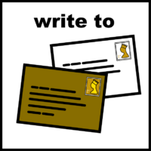 | Dear ………………………
 | I am writing as part of the National Care Forum’s Speak Up for Care Campaign because care and support matters to me.
 | I live as a member of the community in [insert the area you live in]
 | The care and support I receive helps me to live life to the full.
 | It is important to me that I get the right support to live a good life.
 | Care and support workers help me to live the life I want to live.
 | The people who support me should be paid a fair wage and shown respect.
 | This isn’t always what happens for care and support workers.
 | I want people to see social care as important, like the NHS – I am sure you do too.
 | I would love to talk about this important issue with you.
 | Please come and meet me and my support workers at [insert the name of where you live]
 | When you visit you will be able to find out more about the care I receive and the services I use to help me live my life to the fullest.
 | Get in touch with me via my support worker at [insert the name of where you live] using the following address/email [insert your full address or email address]
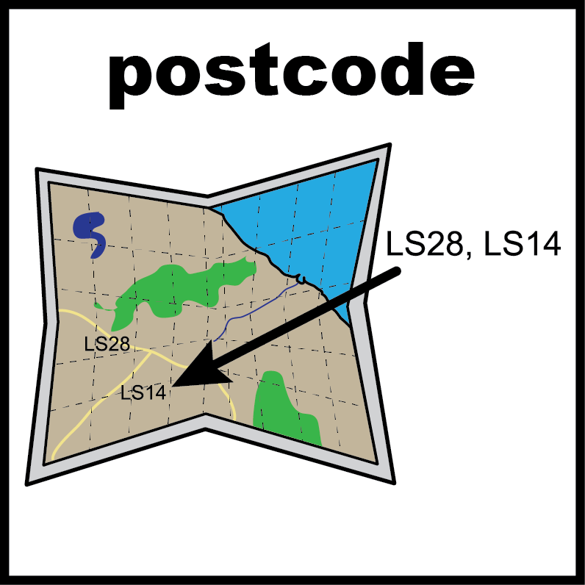 | It is very important that you include your postcode when you write down your address.

